**SQL queries and outputs of *e_commerce data analysis project***

**Basic Queries**

**1. List all unique cities where customers are located.**

**Code:**

*SELECT DISTINCT customer_city*

*FROM customers;*

**Output:**

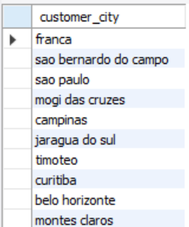

**2. Count the number of orders placed in 2017.**

**Code:**

*SELECT COUNT(order_id) AS num_orders_2017*

*FROM orders*

*WHERE YEAR(order_purchase_timestamp) = 2017;*

**Output:**

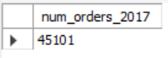

**3. Find the total sales per category.**

**Code:**

*SELECT p.product_category AS product_category, ROUND(SUM(oi.price + oi.freight_value),2) AS category_sales -- if we want to include shipping cost as well*

*FROM products p*

*JOIN order_items oi ON oi.product_id = p.product_id*

*GROUP BY p.product_category*

*ORDER BY category_sales DESC;*

**Output:**

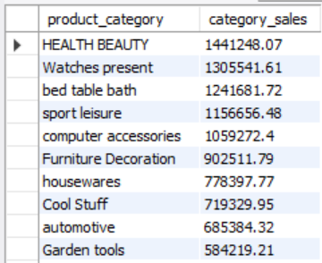

**Code:**

*SELECT p.product_category AS product_category, ROUND(SUM(oi.price),2) AS category_sales -- if we don't want to include shipping cost as well*

*FROM products p*

*JOIN order_items oi ON oi.product_id = p.product_id*

*GROUP BY p.product_category*

*ORDER BY category_sales DESC;*

**Output:**

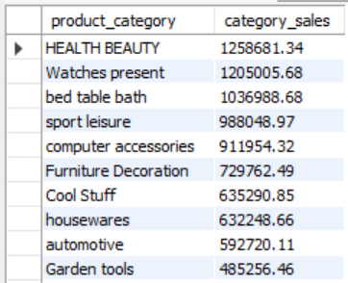

**4. Calculate the percentage of orders that were paid in installments.**

**Code:**

*SELECT*

*COUNT((CASE WHEN payment_installments > 1 THEN order_id END))*100/COUNT(*) AS perc_of_installment_orders*

*FROM payments;*

**Output:**

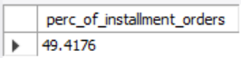

**Code:**

*SELECT -- Considering payment_installments = 1 as installment as there are few rows with payment_installments = 0*

*COUNT((CASE WHEN payment_installments >= 1 THEN order_id END))*100/COUNT(*) AS perc_of_installment_orders*

*FROM payments;*

**Output:**

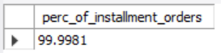

**5. Count the number of customers from each state.**

**Code:**

*SELECT*

*customer_state, COUNT(customer_id) AS num_customers*

*FROM customers*

*GROUP BY customer_state*

*ORDER BY num_customers DESC;*

**Output:**

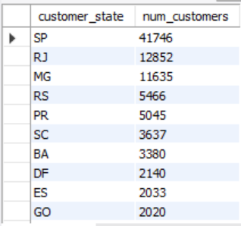

**Intermediate Queries**

**1. Calculate the number of orders per month in 2018.**

**Code:**

*WITH num_orders_2018 AS(*

*SELECT*

*MONTHNAME(order_purchase_timestamp) AS month_of_2018,*

*MONTH(order_purchase_timestamp) AS month_num,*

*COUNT(order_id) AS num_orders*

*FROM orders*

*WHERE YEAR(order_purchase_timestamp) = 2018*

*GROUP BY month_of_2018, month_num*

*ORDER BY month_num*

*)*

*SELECT month_of_2018, num_orders*

*FROM num_orders_2018;*

**Output:**

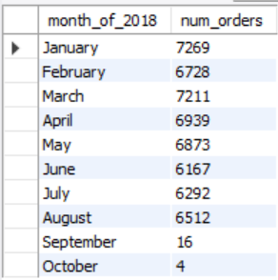

**2. Find the average number of products per order, grouped by customer state.**

**Code:**

*WITH state_order_items AS (*

*SELECT*

*c.customer_state, oi.order_id, COUNT(*) AS num_items*

*FROM order_items oi*

*JOIN orders o ON o.order_id = oi.order_id*

*JOIN customers c ON c.customer_id = o.customer_id*

*GROUP BY c.customer_state, oi.order_id*

*)*

*SELECT*

*customer_state, AVG(num_items) AS avg_items_per_order*

*FROM state_order_items*

*GROUP BY customer_state*

*ORDER BY avg_items_per_order DESC;*

**Output:**

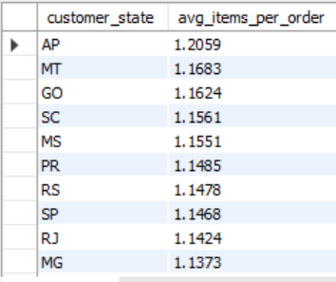

**3. Calculate the percentage of total revenue contributed by each product category.**

**Code:**

*SELECT*

*p.product_category,*

*ROUND(SUM(oi.price)*100/(SELECT SUM(price) FROM order_items),2) AS perc_contribution_in_sales*

*FROM order_items oi*

*JOIN products p ON p.product_id = oi.product_id*

*GROUP BY p.product_category*

*ORDER BY perc_contribution_in_sales DESC;*

**Output:**

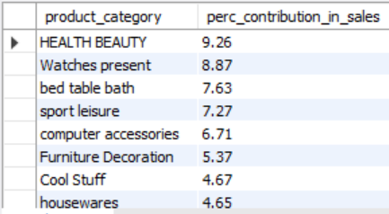

**4. Identify the correlation between product price and the number of times a product has been purchased(total no. of products here will be from product_category)**

**Code:**

*SELECT*

*p.product_category,*

*COUNT(oi.product_id) AS total_items_puchased,*

*ROUND(SUM(oi.price),2) AS sales_amount,*

*ROUND(AVG(price),2) AS avg_price_per_item*

*FROM order_items oi*

*JOIN products p ON p.product_id = oi.product_id*

*GROUP BY p.product_category;*

*/\**

*Correlation in python - code*

*query = """SELECT*

*p.product_category,*

*COUNT(oi.product_id) AS total_items_puchased,*

*ROUND(SUM(oi.price),2) AS sales_amount,*

*ROUND(AVG(price),2) AS avg_price_per_item*

*FROM order_items oi*

*JOIN products p ON p.product_id = oi.product_id*

*GROUP BY p.product_category;"""*

*cur.execute(query)*

*data = cur.fetchall()*

*df = pd.DataFrame(data,columns = ["product_category", "total_items_puchased", "sales_amount", "avg_price_per_item"])*

*df.head()*

*import numpy as np*

*arr1 = df["total_items_puchased"]*

*arr2 = df["avg_price_per_item"]*

*a = np.corrcoef([arr1,arr2])*

*print(f"The correlation coefficient is \033[1m{round(a[0][-1],3)}\033[0m." )*

*\*/*

**Output:**

**SQL Table**

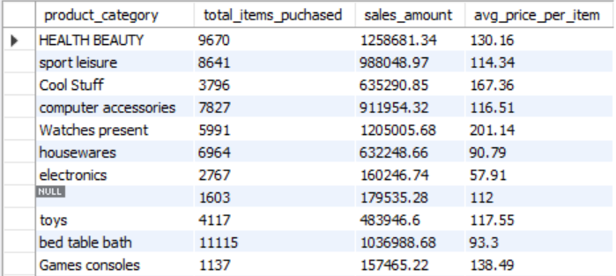

**Python**

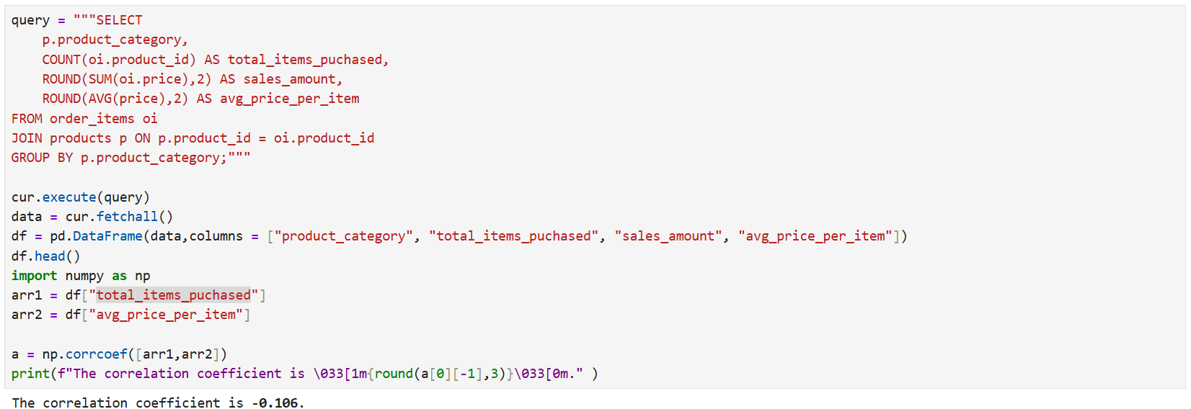

**5. Calculate the total revenue generated by each seller, and rank them by revenue.**

**Code:**

*SELECT*

*oi.seller_id, ROUND(SUM(payment_value),2) AS seller_revenue,*

*DENSE_RANK() OVER(ORDER BY SUM(payment_value) DESC) AS seller_rank*

*FROM order_items oi*

*JOIN payments p ON p.order_id = oi.order_id*

*GROUP BY oi.seller_id;*

**Output:**

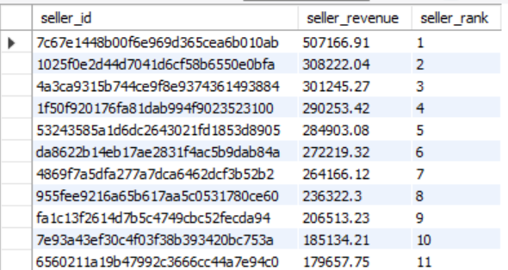

**Advanced Queries**

**1. Calculate the moving average of order values for each customer over their order history.(say moving average of last 3 orders)**

**Code:**

*SELECT*

*t.customer_id, t.order_purchase_timestamp, t.payment_value, customer_order_count, moving_avg_3_orders*

*FROM(SELECT*

*o.customer_id, o.order_purchase_timestamp, p.payment_value,*

*COUNT(*) OVER (PARTITION BY o.customer_id) AS customer_order_count,*

*ROUND(AVG(p.payment_value)OVER(PARTITION BY o.customer_id ORDER BY o.order_purchase_timestamp ROWS*

*BETWEEN 2 PRECEDING AND CURRENT ROW),2) AS moving_avg_3_orders*

*FROM orders o*

*JOIN payments p ON p.order_id = o.order_id) AS t*

*WHERE customer_order_count > 1*

*-- customers with More than 1 order will be filtered in this data and*

*-- hence moving average will be calculated as per 2, 3, 4 or more orders*

*;*

**Output:**

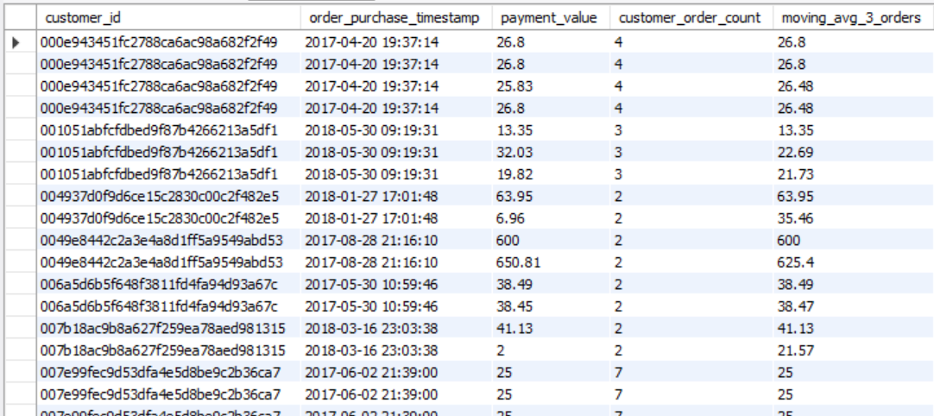

**2. Calculate the cumulative sales per month for each year.**

**Code:**

*WITH monthly_sales AS (*

*SELECT*

*YEAR(o.order_purchase_timestamp) AS year, MONTH(o.order_purchase_timestamp) AS month_num, MONTHNAME(o.order_purchase_timestamp) AS month,*

*ROUND(SUM(p.payment_value),2) AS monthly_sales*

*FROM orders o*

*JOIN payments p ON p.order_id = o.order_id*

*GROUP BY year, month_num, month*

*ORDER BY year, month_num*

*)*

*SELECT*

*year, month, monthly_sales,*

*ROUND(SUM(monthly_sales) OVER(ORDER BY year, month_num),2) AS monthly_cumulative_sales*

*FROM monthly_sales;*

**Output:**

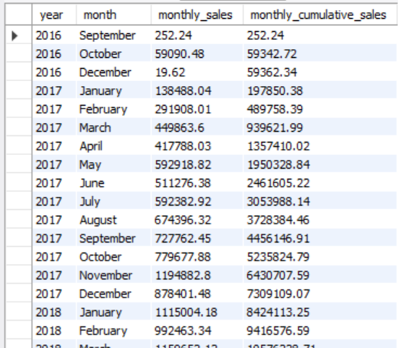

**3. Calculate the year-over-year growth rate of total sales.**

**Code:**

*SELECT*

*year, yearly_sales, previous_year_sales,*

*ROUND((yearly_sales - previous_year_sales)*100/previous_year_sales,2) AS YoY_growth_percent*

*FROM (SELECT*

*YEAR(o.order_purchase_timestamp) AS year, ROUND(SUM(p.payment_value),2) AS yearly_sales,*

*LAG(ROUND(SUM(p.payment_value),2),1) OVER(ORDER BY YEAR(o.order_purchase_timestamp)) AS previous_year_sales*

*FROM orders o*

*JOIN payments p ON p.order_id = o.order_id*

*GROUP BY year) AS year_sale;*

**Output:**

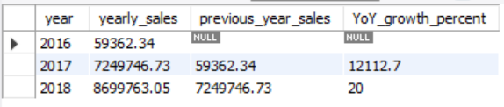

**4. Calculate the month_on_month growth rate of total sales.**

**Code:**

*WITH monthly_sales AS (*

*SELECT*

*YEAR(o.order_purchase_timestamp) AS year, MONTH(o.order_purchase_timestamp) AS month_num, MONTHNAME(o.order_purchase_timestamp) AS month,*

*ROUND(SUM(p.payment_value),2) AS monthly_sales*

*FROM orders o*

*JOIN payments p ON p.order_id = o.order_id*

*GROUP BY year, month_num, month*

*ORDER BY year, month_num*

*)*

*SELECT*

*year, month, monthly_sales,*

*LAG(monthly_sales,1) OVER(ORDER BY year, month_num) AS prev_month_sale,*

*ROUND((monthly_sales - LAG(monthly_sales,1) OVER(ORDER BY year, month_num))*100/LAG(monthly_sales,1) OVER(ORDER BY year, month_num),2) AS*

*Mom_growth*

*FROM monthly_sales;*

**Output:**

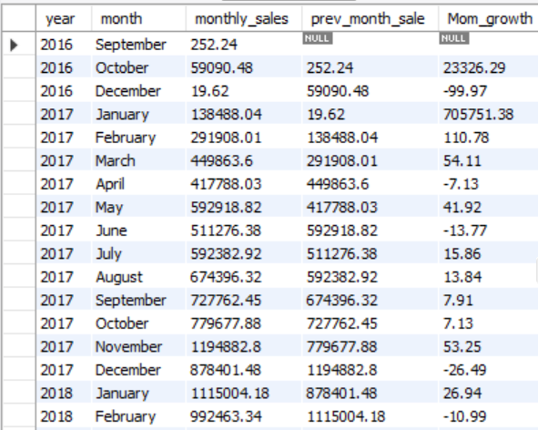

**5. Identify the top 3 customers who spent the most money in each year.**

**Code:**

*WITH customer_spending AS (SELECT*

*YEAR(o.order_purchase_timestamp) AS year,*

*o.customer_id, ROUND(SUM(p.payment_value),2) AS spent,*

*-- Don't partition by customer_id because then every customer will be assigned a new group and respective rank i.e. 1*

*DENSE_RANK() OVER(PARTITION BY YEAR(o.order_purchase_timestamp) ORDER BY ROUND(SUM(p.payment_value),2) DESC) AS customer_rank_in_year*

*FROM orders o*

*JOIN payments p ON p.order_id = o.order_id*

*GROUP BY year, o.customer_id*

*ORDER BY year)*

*SELECT*

*year, customer_id, spent, customer_rank_in_year*

*FROM customer_spending*

*WHERE customer_rank_in_year <= 3;*

**Output:**

